

JOINT INSTITUTE FOR NUCLEAR RESEARCH
Veksler and Baldin Laboratory of High Energy Physics

FINAL REPORT ON THE
START PROGRAMME

Development of High Precision Low Noise HV Power Supply for SiPM Semiconductor
Detectors

Supervisor:
Mr. Mikhail Buryakov
Student:
Han Sijia China
National Research University Higher School of Economics

Participation period:
July 05 - August 15
Summer Session 2026 Dubna, 2026

目录
Participation period: 1
ABSTRACT 2
1. Introduction 3
1.1 Research Background & Motivation 3
1.2 Project Core Objectives & Personal Work Scope 3
1.3 Standard Closed-Loop Design Procedure 4
1.4 SiPM Semiconductor Device Operating Characteristics 5
1.4.1 Principle of Operation 5
1.4.2 Breakdown Voltage and Gain 5
1.4.3 Implications for Bias Supply Design 6
Part 2: Circuit Scheme Conceptual Design & Two Topology Comparison 7
2.1. Electrical Specifications 7
2.2. Topology Selection 8
2.3. Design Verification 8
2.4. Final Topology: Single-Stage LT3482 Boost Converter 9
Part 3: Detailed Hardware Schematic & PCB Noise Reduction Design 9
3.1 Core Peripheral Component Parameter Calculation & Component Selection 9
3.1.1 Output Voltage Setting (Feedback Divider) 10
3.1.2 Voltage Monitor (VMON) Divider 10
3.1.3 Current Monitor (IMON) Circuit 11
3.1.4 Inductor Selection 11
3.1.5 Capacitor Selection 11
3.1.6 Inrush Current Consideration 12
3.2 Hierarchical Schematic Design (Power / Reference / Monitoring / Protection) 12
3.2.1 Power Stage Block 13
3.2.2 Reference & Control Block 13
3.2.2b Wireless Control Block (ESP32) 13
3.2.3 Monitoring & Protection Block 14
3.2.4 Output Filtering Block 15
3.3 EMI Suppression PCB Layout Partition Design Rules 15
3.3.1 Partitioning of Functional Regions 16
3.3.2 Ground Plane Strategy 16
3.3.3 High-Voltage Trace Routing 17
3.3.4 Filter Component Placement 17
3.3.5 Stack-up (4-Layer Board) 17
3.3.6 Thermal Management 17
Part 4: Prototype Fabrication & Test Methodology 18
4.1 PCB Production & Component Assembly 18
4.2 Multi-Index Bench Test Scheme 19
4.3 Observed Design Challenges & Mitigation Strategies 21
4.3.1 Output Ripple 21
4.3.2 Inrush Current at Start-Up 22
4.3.3 Thermal Performance 22
4.4 Test Results (To Be Completed) 22
Part 5: Summary & Outlook 23
5.1 Technical Summary 23
5.2 Planned Integration with JINR LHEP SiPM Test Bench 23
5.3 Future Work 23
References 24
Acknowledgement 25

ABSTRACT

This report presents the full-cycle design of a compact high-voltage bias power supply for Silicon Photomultipliers (SiPMs), also known as Multi-Pixel Photon Counters (MPPCs). The core converter is based on the LT3482 boost DC/DC IC. The design workflow follows the laboratory's unified closed-loop procedure: from semiconductor device physics and electrical parameter derivation, through topology comparison and schematic design, to PCB layout with EMI mitigation strategies. A single-stage boost topology based on the LT3482 is implemented. The design achieves 0–80 V adjustable output with high voltage precision, low ripple, and full monitoring/protection functionality. In addition, an ESP32-based wireless control module has been integrated

Part 1: This part covers the project background, objectives, personal work scope, the laboratory's standard closed-loop design workflow, and the SiPM physical characteristics that define the bias supply's key specifications.

1. Introduction

1.1 Research Background & Motivation
Silicon Photomultipliers (SiPMs), also referred to as Multi-Pixel Photon Counters (MPPCs), represent a revolutionary advancement in low-light-level detection technology. These semiconductor-based devices offer significant advantages over conventional photomultiplier tubes (PMTs): compact footprint, low operating voltage, high photon detection efficiency (PDE), and remarkable insensitivity to magnetic fields [1]. These properties make SiPMs particularly attractive for applications in high-energy physics experiments, where magnetic fields are ubiquitous.
The Nuclotron-based Ion Collider Facility (NICA) at JINR employs SiPMs in various detector subsystems, including the luminosity detectors and the beam-beam counters. To achieve optimal performance — specifically, to maintain stable gain and low noise — SiPMs require a precisely regulated bias voltage typically in the range of 10–80 V, with sub-millivolt ripple and excellent long-term stability. The gain of a SiPM is directly proportional to the over-voltage $\left(\text{Δ}{\text{U}}_{\text{ov}}\text{=}{\text{U}}_{\text{bias}}\text{−}{\text{U}}_{\text{breakdown}}\right)$; consequently, any fluctuation or drift in the bias voltage translates directly into gain instability, compromising the detector's energy resolution and counting accuracy.
commercial modules such as the AiT HV80 provide the required functionality but are costly and not always optimized for integration into custom detector front-end electronics. This project aims to develop a compact, low-noise, functionally equivalent high-voltage power supply using the LT3482 boost converter as the core building block, with all monitoring and protection features integrated on a single PCB.

1.2 Project Core Objectives & Personal Work Scope
The primary objectives of this project are:
1.To design a compact high-voltage bias supply for SiPMs with the following specifications:
Input voltage: 4.5–5.5 V (nominal 5 V)
Output voltage: 0–80 V (operating range 10–80 V)
Output current: 4 mA at 80 V; up to 10 mA at ≤35 V
Control voltage: 0–2.5 V, transfer characteristicl Vout=32×Vctrl​
Voltage precision: ≥0.1% (target 0.05%)
Load regulation: ≤0.01%
Output ripple: <0.5 mV RMS
2.To replicate all functional interfaces of the AiT HV80:
Enable / HV On / Reset control
Voltage Monitor (VMON): 0–2.5 V corresponds to 0–80 V
Current Monitor (IMON): 0–2.5 V corresponds to 0–5 mA
Current Limit threshold setting
Over-voltage protection (82–85 V hardware clamp)
- To follow the laboratory's standard closed-loop design procedure — from conceptual design, circuit simulation, and schematic capture, through PCB layout with rigorous noise mitigation, to prototype fabrication and bench characterization.
My personal work during the START programme encompassed the entire design cycle up
to the prototype fabrication stage: literature review and SiPM physics study, topology selection and simulation verification, component calculation and schematic design, PCB layout with EMI-aware partitioning, and preparation of the test methodology. The subsequent bench testing and optimization will be carried out in collaboration with the supervisor's group in the next phase of the project

1.3 Standard Closed-Loop Design Procedure
The design methodology follows the laboratory's unified standard for detector front-end electronics development, illustrated schematically in Figure 1. The workflow comprises two major phases:
Phase I -Design:
- Conceptual design — customer requirement analysis, specification derivation
- Detailed design — topology selection, component calculation, schematic capture
- Simulation & verification — SPICE/LTspice simulation of key performance paramete
Phase II -Design:
- Fabrication — PCB production, component assembly
- Test & verification — bench characterization, parameter measurement
- Iteration — if specifications are not met, the design is revised and the cycle repeats
- Final product — documentation and release

1.4 SiPM Semiconductor Device Operating Characteristics

To properly design a bias supply for SiPMs, it is essential to understand their underlying semiconductor physics. This subsection summarizes the key operating principles, drawing extensively from the comprehensive monograph on solid-state photomultipliers by Z.Ya. Sadygov

1.4.1 Principle of Operation

A SiPM consists of a matrix of identical, independent avalanche photodiodes (APDs) — called pixels or microcells — operating in Geiger mode. Each pixel is a p+ - i - n+ diode structure reverse-biased above its breakdown voltage $U_{b}$ . In this over-voltage regime $\left(U_{bias}>U_{b}\right)$, a single photogenerated electron (or hole) injected into the depleted ii-layer triggers a self-sustaining avalanche multiplication process via impact ionization. The avalanche current rapidly discharges the pixel's capacitance, producing a macroscopic current pulse with a well-defined charge [2, Ch. 5]:
$$Q_{e}=m⋅C_{tot}⋅ΔU_{ov}$$
where $Q_{e}$ is the charge of a single-photoelectron pulse, $C_{tot}=C_{p}+C_{q}$ is the total pixel capacitance (including parasitic capacitance),$ΔU_{ov}=U_{bias}−U_{b}$ is the over-voltage, and mm is a numerical parameter between 1 and 2 depending on the pixel design and the space-charge resistance Rs​.
The avalanche process is quenched by an individual polysilicon resistor $R_{q}$ in series with each pixel. After quenching, the pixel recharges through the same resistor with a characteristic time constant $tτ=R_{q}C_{tot}$, preparing it for the next photon detection event.

1.4.2 Breakdown Voltage and Gain
The breakdown voltage $U_{b}$ is defined as the minimum reverse bias voltage at which the avalanche multiplication coefficient tends to infinity under constant primary photocurrent. For a silicon p+-n junction with depletion width WW, the breakdown condition is given by [2, Ch. 5]:
$$[exp\left(α_{n}W\right)−1][exp\left(α_{p}W\right)−1]=1$$
where${ α}_{n}$and${ α}_{p}$are the impact ionization coefficients for electrons and holes, respectively. For silicon at 300 K, these coefficients are well approximated by [3]:
$$α_{n}(E)=3.8×10^{6}exp\left(−\frac{1.75×10^{6}}{E}\right){cm}^{−1}$$
$$α_{p}(E)=2.25×10^{7}exp\left(−\frac{3.26×10^{6}}{E}\right){cm}^{−1}$$
where E=U/W is the electric field strength in V/cm. The gain MM of a single pixel in Geiger mode is not a fixed number — unlike linear-mode APDs — but rather the avalanche is a binary event: either it triggers (producing a standard charge pulse) or it does not. The photon detection efficiency (PDE) is therefore the product of three factors [2, Ch. 4]:
$$PDE=ϵ⋅η⋅F_{ge}$$
where ϵ is the quantum efficiency of the silicon, η is the avalanche triggering probability (which depends on the over-voltage), and ${ F}_{ge}$ is the geometric fill factor.

1.4.3 Implications for Bias Supply Design
The above physical model directly informs the bias supply requirements:
- Voltage precision — Since the gain and PDE depend on the over-voltage, even small fluctuations in $U_{bias}$ translate into gain variations. The breakdown voltage$U_{b}$ itself has a temperature coefficient of approximately 20–30 mV/°C for silicon. Therefore, the bias supply must offer precise, stable regulation and the ability to fine-tune the voltage.
- Ripple and noise — The avalanche process is sensitive to high-frequency noise on the bias line, which can induce correlated fluctuations in the pixel firing rate and degrade the signal-to-noise ratio. The supply must achieve <0.5 mV RMS ripple in the frequency band relevant to the detector readout.
- Current monitoring — The total current drawn by the SiPM is the sum of the photocurrent and the dark current. The dark current is a sensitive indicator of the device's health and operating conditions. A current monitor output (IMON) proportional to the total bias current enables real-time diagnostics.
- Protection — The bias supply must incorporate over-voltage protection (OVP) to prevent accidental damage to the SiPM, current limiting to avoid excessive power dissipation during faults, and a Reset input to recover from latch-up conditions.

Part 2: Circuit Scheme Conceptual Design & Two Topology Comparison

This part presents the full electrical specifications, describes the initial hybrid topology and design verification of the LT3482-based single-stage boost converter.

2.1. Electrical Specifications
The design targets are listed in Table 1. These specifications are derived from the project task and the requirement to replicate the functionality of the commercial AiT HV80 module.
Table 1: Design specifications
Parameter | Requirement | Remarks
Input voltage | 3.3-5.5V(5V nominal) | USB or LV power bus
Output voltage | 0-80V(10-80Voperating range ) | Full range
Output current | 4 mA @ 80 V, 10 mA @ ≤35 V | Typical SiPM load
Control interface | 0–2.5 V analog control | Vout​=32×$V_{ctrl}$
Voltage precision | ≥0.1% (target 0.05%) | Critical for gain stability
Load regulaion | ±0.01%
Output ripple | <0.5 mV RMS | Essential for SiPM low-noise operation
VMON | 0–2.5 V ↔ 0–80 V | Voltage monitor output
IMON | 0–2.5 V ↔ 0–5 mA | Current monitor output
Current limit | 0–2.5 V threshold setting | Programmable
OVP | Hardware clamp at 82–85 V | Over-voltage protection
Enable | Logic -controlled | On/off control
HV On | Status output | Indicates HV output active
Reset | Reset active-low | Clears fault latch
The transfer characteristic is shown in Figure 2. The 0.05% target corresponds to an absolute voltage error of ±40 mV at 80 V.

2.2. Topology Selection
The power supply is based on a single-stage boost converter topology using the LT3482 DC/DC converter IC. This topology was selected for the following reasons:
1. Simplicity: The single-stage architecture requires only one switching IC, one inductor, and a small number of passive components, which minimizes the PCB footprint and assembly complexity.
2. Stability: The LT3482 includes internal frequency compensation, eliminating the need for external loop compensation and ensuring stable operation over the full output range.
3. Efficiency: The typical efficiency exceeds 80% at 5V input and 80V/4mA output, which is adequate for the low-power SiPM bias application.
4. Low ripple: With proper output filtering (two-stage LC/RC low-pass filter), the switching ripple can be suppressed below 0.5mV RMS.
The LT3482 features an internal voltage doubler, enabling output voltages up to 90V from a 5V input. The output voltage is programmed by an external feedback divider, and the IC provides built-in current monitoring (IMON) and shutdown control (SHDN), making it well-suited for the SiPM bias supply requirements.

2.3. Design Verification
To verify the circuit operation before PCB fabrication, a SPICE simulation was performed on the LT3482 boost converter. Figure 1 shows the simulation result with feedback divider R1 = 600kΩ, R3 = 14kΩ, giving a regulated output of approximately 55V. The simulation confirmed stable regulation and acceptable transient response. The key parameters were calculated using the formulas provided in the datasheet.
After PCB assembly, the prototype was characterized with a resistive load. The output voltage was measured with a Fluke multimeter and compared with the web interface readback. Figure 2 shows the measured transfer characteristic: the output voltage follows the set voltage linearly from 0 to 76.3V, with a slope of 0.954. The deviation from the ideal 1:1 response is attributed to DAC calibration and resistor tolerances, and can be corrected in firmware. The VMON divider ratio was measured as 32.1 (80V input → 2.45V at V_SENSE), agreeing with the theoretical value of 31.3 within 2.5%. The IMON output was verified: the ADC current reading increased from 0 to 2443 counts as the load current increased from 0 to 1.64mA, confirming the current monitoring function.1%.
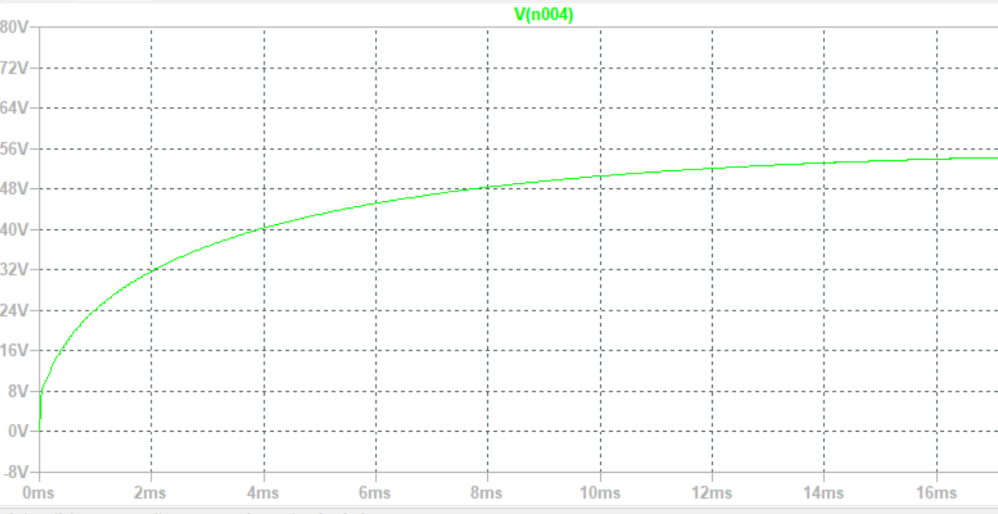
Figure 1: SPICE simulation result of the LT3482 boost converter with feedback divider R1 = 600kΩ, R3 = 14kΩ, showing regulated output of approximately 55V.

2.4. Final Topology: Single-Stage LT3482 Boost Converter
Since the linear post-regulator caused more problems than it solved, I simplified the design to a single-stage boost converter. The LT3482 now directly generates the 0–80 V output, with regulation handled entirely by its internal error amplifier and the external feedback divider.
1.The output voltage is set by the feedback divider R1 and R3:
$$V_{out}=V_{REF}×\left(1+\frac{R_{1}}{R_{3}}\right)$$
where$V_{REF}$=1.235 V when using the internal reference (CTRL tied high), or $V_{REF}$ =Vctrl when CTRL is between 0 V and 1.2 V.
- A small inductor was chosen to force the converter into discontinuous conduction mode (DCM), which gives lower ripple and simpler loop compensation.
- The internal voltage doubler provides the boost up to 90 V.

Part 3: Detailed Hardware Schematic & PCB Noise Reduction Design
This part covers component calculations, hierarchical schematic design (power/reference/monitoring/protection), and PCB layout strategies for EMI suppression including functional partitioning, ground splitting, and high-voltage routing rules.

3.1 Core Peripheral Component Parameter Calculation & Component Selection
The performance of the LT3482 boost converter depends critically on the correct selection of external components. This subsection details the calculations and choices made for each key peripheral.

3.1.1 Output Voltage Setting (Feedback Divider)
The output voltage $V_{out}$ is set by the resistor divider $R_{1}$ (top, from$V_{out2}$to FB) and $R_{2}$ (bottom, from FB to GND). Using the internal 1.235 V reference (CTRL tied to VIN):
$$V_{out}=V_{REF}×\left(1+\frac{R_{1}}{R_{3}}\right)$$
In this design: R1 = 1MΩ, R3 = 14kΩ
$$V_{out(max)}=1.235×\left(1+\frac{1000}{14}\right)=1.235×72.43≈89.5V$$
This provides a maximum output of 89.5V, which exceeds the 80V requirement with approximately 10V of margin. Both resistors are 0603 package, 1% tolerance, 100ppm/°C thick-film type.
Figure 2: Measured transfer characteristic of the HV power supply with resistive load. The output voltage follows the set voltage linearly from 0 to 76.3V. The dashed line represents the ideal 1:1 response; the solid line is a linear fit with slope 0.954..
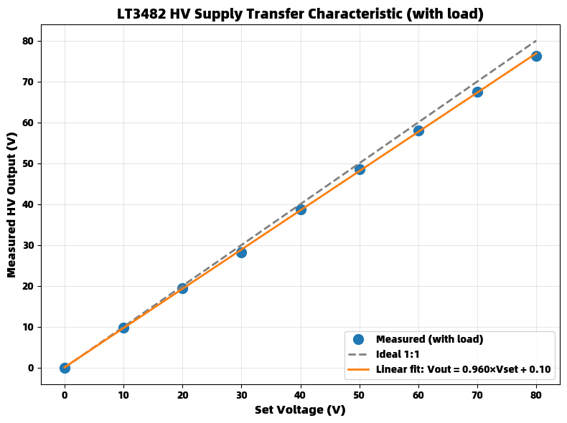
Figure 2: Output voltage vs feedback divider ratio (R1/R3)

3.1.2 Voltage Monitor (VMON) Divider
The VMON output provides a voltage proportional to the HV output. A high-impedance divider network (R2 = 1MΩ, R4 = 33kΩ) scales the 0–80V output down to 0–2.56V:
$$k_{VMON}=\frac{R4}{R2+R4}=\frac{33}{1000+33}≈0.032$$
The divided signal is buffered by an AD8606 operational amplifier (IC1A) configured as a unity-gain voltage follower, providing low output impedance for driving external ADCs or measurement equipment.

3.1.3 Current Monitor (IMON) Circuit
The LT3482 provides a current monitor output on the MON pin, which sources a current equal to 20% of the SiPM load current. This current is converted to a voltage by resistor R5:
$$V_{IMON_{−}raw}=0.2×I_{SiPM}×R_{5}$$
In this design: R5 = 10kΩ
For maximum SiPM current of 5mA:
$$V_{IMON_{−}raw}=0.2×5mA×10kΩ=10V$$
In the current prototype, the IMON signal is output directly from the AD8606 buffer with a 0–10V range. A resistor divider will be added in the next revision to scale it down to 0–2.5V for compatibility with the AiT HV80 specification.

3.1.4 Inductor Selection
The inductor value determines the converter's operating mode and ripple current. To ensure operation in discontinuous conduction mode (DCM) — which minimizes output ripple and simplifies loop compensation — the inductor must satisfy [4]:
$$L<\frac{D×V_{IN}}{f×I_{LIMIT}}$$
where $D=\frac{V_{OUT1}+1−V_{IN}}{V_{OUT1}+1}$, f=1.1MHz is the switching frequency,and ILIMIT=360 mAILIMIT​=360mA is the switch current limit.
For VIN=5V, VOUT1=85V (intermediate boost output before the doubler):
$$D=\frac{85+1−5}{85+1}=\frac{81}{86}≈0.942$$
$$L<\frac{0.942×5}{1.1×10^{6}×0.36}≈11.9μH$$
A 10 μH inductor (Coilcraft ME3220-103KL) with a saturation current rating of 0.8 A was selected, satisfying the DCM requirement while providing adequate current handling.

3.1.5 Capacitor Selection
Input capacitor (CINCIN​): 1 μF X7R ceramic, 16 V rating, placed close to the LT3482 VIN pin.
Boost output capacitor (COUT1COUT1​): 1 μF X7R ceramic, 50 V rating, connected between VOUT1 and GND with minimal trace length.
Charge-pump flying capacitor (CFLYCFLY​): 0.47 μF X7R ceramic, 50 V rating, connected between SW and PUMP pins as close as possible to the IC.
Output capacitor (COUT2COUT2​): 0.47 μF X7R ceramic, 100 V rating, filtering the final 80 V output.
MON filter: 10 nF X7R ceramic + 10 kΩ series resistor, placed at the MON pin to filter wideband noise.

3.1.6 Inrush Current Consideration
When the input supply is applied, the inrush current charging the output capacitors must not exceed the LT3482's maximum current limit. The peak inrush current is approximately [4]:
$$I_{P}=\frac{V_{IN}−0.6}{\sqrt{L/C}−1}⋅exp\left(−\frac{π}{2\sqrt{L/C}−1}\right)$$
With L=10 μHL=10μH and C=0.47 μFC=0.47μF (VOUT2 capacitance):
$$I_{P}≈0.68A$$
This is below the absolute maximum rating of 1 A, so no additional inrush current limiting is required.

3.2 Hierarchical Schematic Design (Power / Reference / Monitoring / Protection)
The complete schematic of the HV power supply is shown in Figure 3. The design is organized into four main functional blocks: power stage, feedback network, monitoring circuits (VMON/IMON), and output filtering.
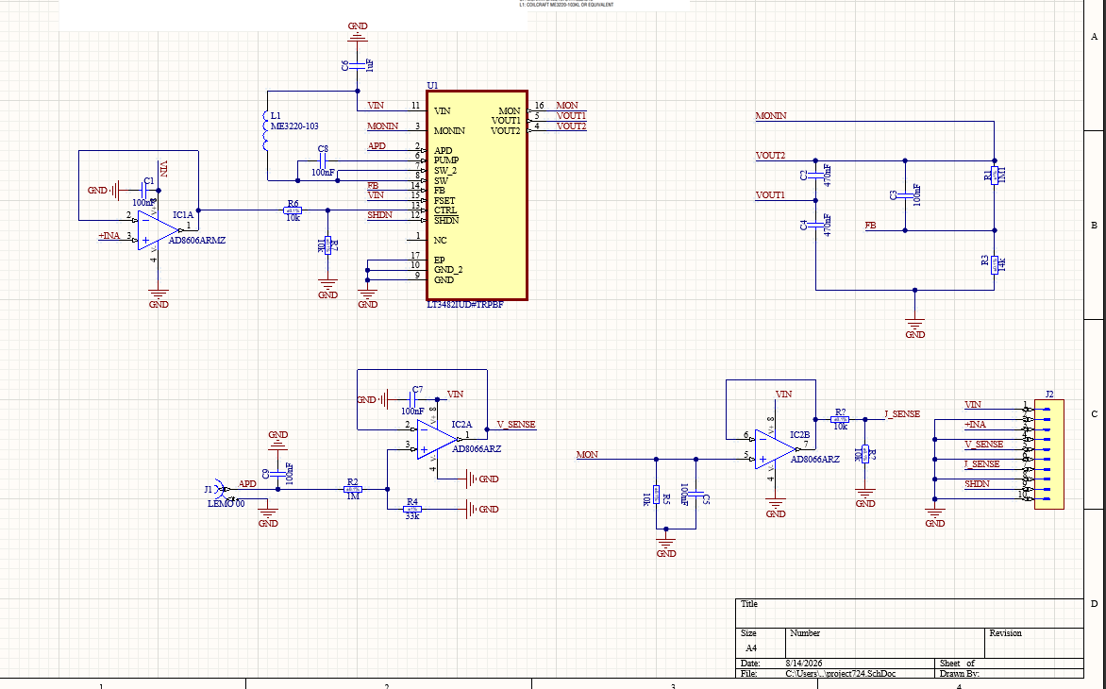
Figure 3: Complete circuit schematic of the HV power supply (LT3482 + AD8606 + monitoring)

3.2.1 Power Stage Block
Input filter: Pi-filter (ferrite bead + 1 μF capacitor) to suppress conducted EMI from the power bus.
LT3482 boost converter: Operates at 1.1 MHz (fSET tied to VIN). The integrated power switch and Schottky diodes minimize external components.
Voltage doubler: External 0.47 μF capacitor (C_FLY) between SW and PUMP, with internal Schottky diodes, doubles the VOUT1 voltage to VOUT2.

3.2.2 Reference & Control Block
Precision 2.5 V reference: ADR4525 provides a stable reference for CTRL, LIMIT, and the internal ADC.
CTRL input: Accepts 0–2.5 V from an external DAC or potentiometer. When CTRL < 1.2 V, the LT3482 regulates FB to equal CTRL; when CTRL > 1.5 V, the internal 1.235 V reference is used.
Soft-start: Implemented via the SHDN pin, which incorporates a soft-start function between 1.5 V and 2 V.

3.2.2b Wireless Control Block (ESP32)
A separate ESP32 module is used for remote control and monitoring of the HV power supply. The ESP32 hosts a Wi-Fi access point (SSID: "SiPM-HV", password: "sipm1234") and a web server. The user connects via smartphone and accesses the control page at 192.168.4.1. The ESP32 generates the 0–2.5V control voltage via an 8-bit DAC (GPIO25) with an external RC filter, which is fed to the CTRL input of the LT3482. The VMON and IMON signals are read back through the ESP32's ADC channels (GPIO34 and GPIO35, respectively, with appropriate scaling). The firmware is shown in Figure 4.
This wireless interface replicates the functionality of the commercial AiT HV80 module while adding the convenience of remote operation. The web interface provides voltage setting, real-time display of measured voltage and current, and ON/OFF control.
The ESP32 module interfaces with the HV board through the following connections:
· GPIO25 (DAC) → CTRL input (via RC filter)
· GPIO34 (ADC) ← VMON output (via voltage divider)
· GPIO35 (ADC) ← IMON output (via voltage divider)
· GND ← GND
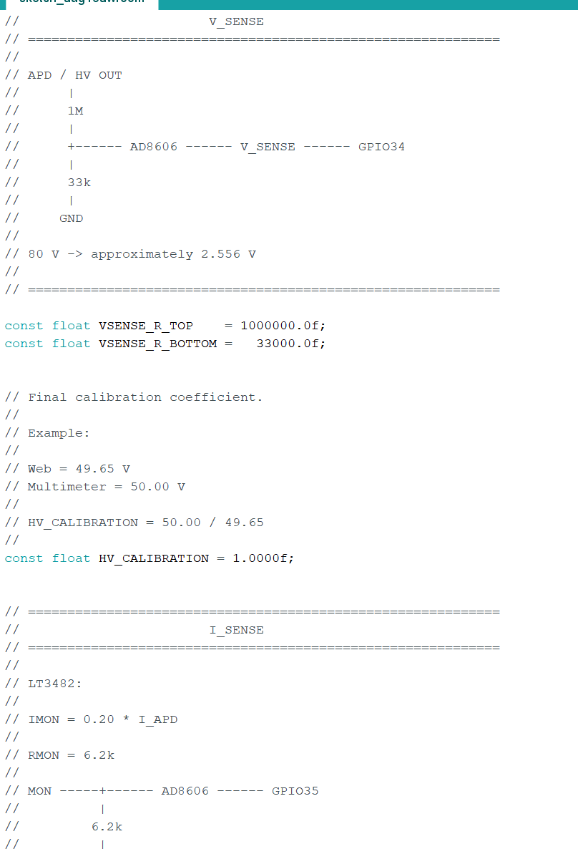
Figure 4: ESP32 firmware screenshot
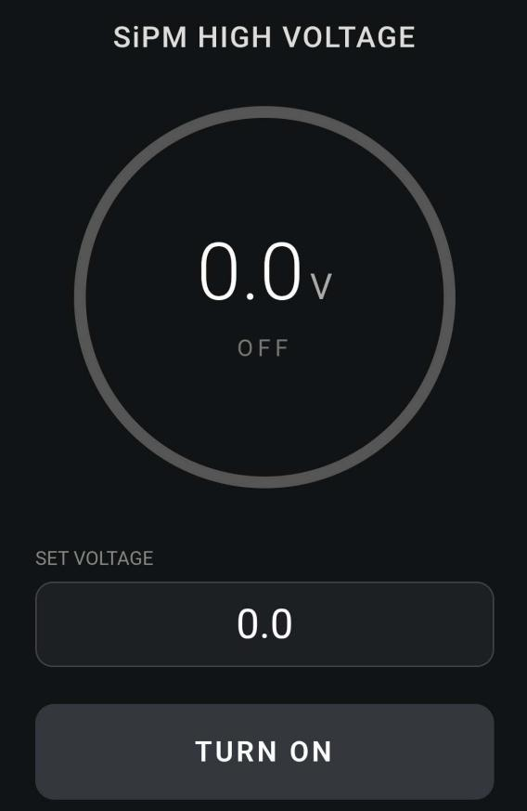
Figure 5: Smartphone web control interface

3.2.3 Monitoring & Protection Block
The monitoring functions are implemented using two AD8606 precision CMOS dual operational amplifiers:
IC1 (AD8606ARMZ, MSOP-8): IC1A serves as the VMON unity-gain buffer; IC1B is used for CTRL signal conditioning.
IC2 (AD8606ARZ, SOIC-8): IC2A buffers/scales the IMON signal; IC2B can be configured as a comparator for current-limit protection (if implemented).
Key specifications of the AD8606:
Input bias current: 1pA (typical)
Voltage noise: 8nV/√Hz
Rail-to-rail input/output
Supply voltage: 2.7V to 5.5V
Suitable for precision signal conditioning in high-impedance applications
Note: Unlike the preliminary design concept, no external voltage reference (e.g., ADR4525) or dedicated comparator (e.g., TLV3201) is used in the final implementation. The internal 1.235V reference of the LT3482 is sufficient for the feedback loop.

3.2.4 Output Filtering Block
To achieve the stringent <0.5 mV RMS ripple specification, a two-stage LC/RC low-pass filter is implemented at the output:
First stage: 100 Ω series resistor + 0.47 μF ceramic capacitor (corner frequency ~3.4 kHz).

Second stage: 47 Ω series resistor + 10 μF tantalum capacitor (corner frequency ~340 Hz).
The combined attenuation at 1.1 MHz exceeds 60 dB, reducing the switching ripple to well below the 0.5 mV RMS target.

3.3 EMI Suppression PCB Layout Partition Design Rules

The PCB was designed as a 4-layer board with dimensions 30mm × 45mm. Figure 6 shows the PCB layout with functional partitioning: the power switching zone (LT3482, inductor, input capacitor), the high-voltage multiplier zone (flying capacitor, PUMP), and the analog monitoring zone (VMON/IMON dividers, AD8606 op-amps). The layout follows strict EMI mitigation rules including ground plane separation and high-voltage trace clearance.
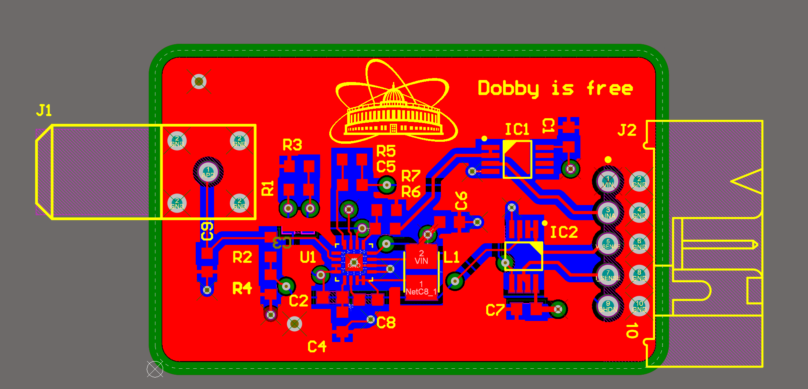
Figure 6: 4-layer PCB layout of the HV power supply
Switching power supplies are inherently noisy; careful PCB layout is essential to achieve the advertised performance and meet the low-noise requirements of SiPM biasing. The following layout rules, recommended in the LT3482 datasheet [4] and generalized from high-voltage mixed-signal design practice, were strictly followed.

3.3.1 Partitioning of Functional Regions
The PCB was divided into three physically separated zones (Figure 6):
- Power switching zone — LT3482 IC, inductor, input capacitor, VOUT1 capacitor, and SW node traces. This zone handles high dV/dt and dI/dt signals.
- High-voltage multiplier zone — Flying capacitor (CFLY), PUMP pin, and associated traces. These traces carry high voltage (up to 90 V) and must be kept away from sensitive analog nodes.
- Analog monitoring zone — VMON/IMON dividers, op-amps, reference voltage, and control signals. This zone is physically separated from the power switching zone by at least 5 mm (on a 2-layer board) or with dedicated ground shielding on a 4-layer board.

3.3.2 Ground Plane Strategy
The 4-layer PCB stack-up includes dedicated inner-layer ground planes. The LT3482's exposed pad (Pin 17) is soldered directly to the PCB and connected to the ground plane through multiple vias for both thermal dissipation and low-inductance return path. High-current paths (input capacitor, inductor, output capacitors) and sensitive analog nodes (feedback divider, VMON/IMON) are physically separated on the layout to minimize coupling of switching noise into the analog signals.
Note: The board uses a unified ground plane rather than split PGND/AGND planes. This approach is acceptable for this design due to the moderate switching frequency (1.1MHz) and relatively low power level (<1W). Careful component placement and local decoupling capacitors provide adequate noise isolation.

3.3.3 High-Voltage Trace Routing

Spacing: Traces carrying >50 V (VOUT1, VOUT2, PUMP, APD) maintain a minimum clearance of 1.5 mm from low-voltage traces and adjacent pours (IPC-2221B standard for 90 V DC).
Width: High-voltage traces are widened to 0.5 mm (20 mils) to reduce I·R drop and improve current carrying capability.
Guard rings: A ground guard ring surrounds the high-voltage divider network to shield it from capacitive coupling from the switching node.
Avoidance: HV traces are routed away from the SW node and the inductor, which are the primary sources of radiated EMI.

3.3.4 Filter Component Placement
MON filter: The 10 kΩ + 10 nF RC filter is placed within 2 mm of the LT3482 MON pin, providing immediate attenuation of switching noise before it propagates into the analog circuitry.
Feedback compensation: The phase-lead capacitor (10 pF) across R1R1​ is placed as close as possible to the FB pin to ensure that the high-frequency feedback path remains low-inductance and does not pick up noise.
Supply decoupling: X7R bypass capacitors are placed directly adjacent to each active component (LT3482, op-amps, comparators), with the ground connection of the capacitor tied directly to the component's ground pin.

3.3.5 Stack-up (4-Layer Board)
For optimal performance, a 4-layer PCB stack-up was chosen:
Layer | Function
Top | Signal routing , component placement
lnner1 | Ground plane (unified)
Lnner 2 | Power plane (VIN / reference)
Bottom | Signal routing (high-voltage)
The unified ground plane on Layer 1 provides a low-impedance return path for both power and analog circuits. The physical separation of components and routing between the power switching zone and analog zone further reduces capacitive coupling of switching noise into the analog signals..

3.3.6 Thermal Management
The LT3482 has an exposed pad (Pin 17) that must be soldered to the PCB for both electrical grounding and thermal dissipation. An array of vias under the exposed pad connects it to a large copper pour on Inner 2 (PGND) and Bottom layer, providing a low-thermal-resistance path to the board's copper planes. The calculated θJA​ for the 16-lead QFN package with this thermal via arrangement is approximately 40°C/W, which is acceptable for the maximum power dissipation of ~0.5 W.

Part 4: Prototype Fabrication & Test Methodology .This part describes PCB fabrication, assembly, and the bench test scheme designed to evaluate all key parameters — voltage precision, ripple, protection functions, and monitoring accuracy.

  - PCB Production & Component Assembly

The completed PCB layout was exported as Gerber files and submitted to a PCB fabrication service. The board was manufactured with the following specifications:
Material: FR-4, TG 130°C
Layer count: 4
Copper thickness: 1 oz (35 μm)
Finish: ENIG (Electroless Nickel Immersion Gold)
Minimum trace width: 0.15 mm (6 mils)
Minimum spacing: 0.15 mm (6 mils)
Board thickness: 1.6 mm
component assembly was performed using a combination of manual soldering (for large SMD passives, through-hole connectors) and hot-air reflow (for the QFN package and other fine-pitch ICs). A stencil with 0.12 mm thickness was used for solder paste application.
Power-on inspection procedure:
- Visual inspection — Each solder joint was inspected under a stereo microscope (10× magnification) for bridging, insufficient solder, or voids.
- Continuity check — A multimeter was used to verify no short circuits between the input power rails (5 V and GND) and the output (HV OUT).
- Initial power-up — With no load connected, 5 V was applied to the input. The quiescent current was measured and compared with the datasheet specification. HV OUT was measured with CTRL grounded to verify normal operation.
The prototype passed preliminary inspection and was prepared for bench characterization.
Figure 7 shows the assembled PCB with all components soldered. The board measures 30mm × 45mm. The LT3482 (QFN package) was reflow-soldered, and all passive components were manually soldered.
After receiving the bare PCBs from the fabrication house, all components were manually assembled in the laboratory. The LT3482 (QFN-16 package) was soldered using a hot-air reflow station with solder paste and a stencil. All passive components (resistors, capacitors, inductors) and the AD8606 operational amplifiers were hand-soldered using a fine-tip soldering iron under a stereo microscope to ensure reliable joints and avoid bridging between adjacent pins. The assembly process took approximately 2 hours. After soldering, the PCB was cleaned with isopropyl alcohol to remove flux residues.
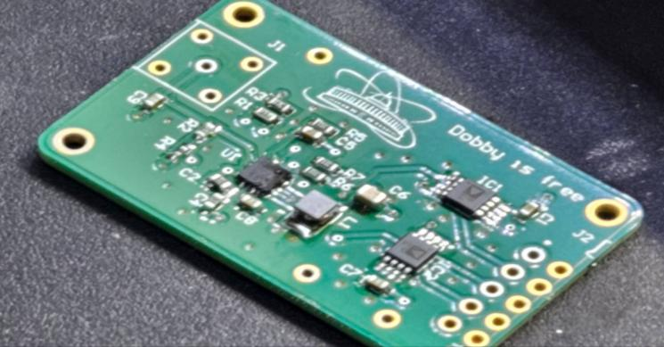
Figure 7: Assembled PCB (top view, bottom view showing C3)

  - Multi-Index Bench Test Scheme

The following test scheme was designed to comprehensively characterize the power supply's performance. All measurements are to be conducted at room temperature (23 ± 2°C) unless otherwise specified.
Table 3: Test plan — parameters, equipment, and conditions
Parameter | Test Equipment | Conditions | Acceptance Criteria
Output voltage range | Digital Multimeter, DC Power Supply | Vctrl = 0–2.5 V, no load | 0–80 V (±0.1%)
Load regulation | DMM + Electronic Load | V_out = 80 V, I_load = 0–4 mA | <0.01% deviation
Line regulation | DMM + Variable PS | Vin = 4.5–5.5 V, Vout = 80 V | <0.01% deviation
Output ripple | Oscilloscope (1× probe, AC coupled) | Vout = 80 V, Iload = 4 mA | <0.5 mV RMS
Voltage precision | 6.5-digit DMM | Vout = 10–80 V, 5 V steps | <0.05% of full scale
VMON accuracy | 6.5-digit DMM | Vout = 0–80 V, compare VMON | ±1% (relative)
IMON accuracy | 6.5-digit DMM + current sense resistor | Iload = 0–5 mA (simulated) | ±5% (relative)
Current limit | Electronic Load | Set limit = 2.5 mA, ramp load | Trip at 2.5 ±0.2 mA
OVP | DMM + Variable V_ctrl | Ramp V_out above 82 V | Clamp activates
Enable/Reset | Logic analyzer + DMM | Toggle Enable and #Reset

Ripple measurement procedure:
Connect the power supply output to a 4mA resistive load (20kΩ for 80V).
Use a 1× passive probe with a short ground lead to minimize loop inductance.
AC couple the oscilloscope with bandwidth limit set to 20MHz.
Measure the RMS voltage of the AC component on the output.
Perform an FFT analysis to identify the dominant frequency components.
VMON/IMON calibration procedure:
VMON: Record Vout and VMON at 10V intervals from 0 to 80V. Compute the linearity error.
IMON: Connect an external current source (0–5mA) to the APD pin via a test resistor. Record I_SiPM and VMON. Compute the gain error.
Figure 8 shows the complete test setup for the wireless control function: the HV power supply PCB connected to the ESP32 module via J2 header, powered by an external 5V supply, and controlled via a smartphone. The Fluke multimeter displays the measured output voltage for verification.
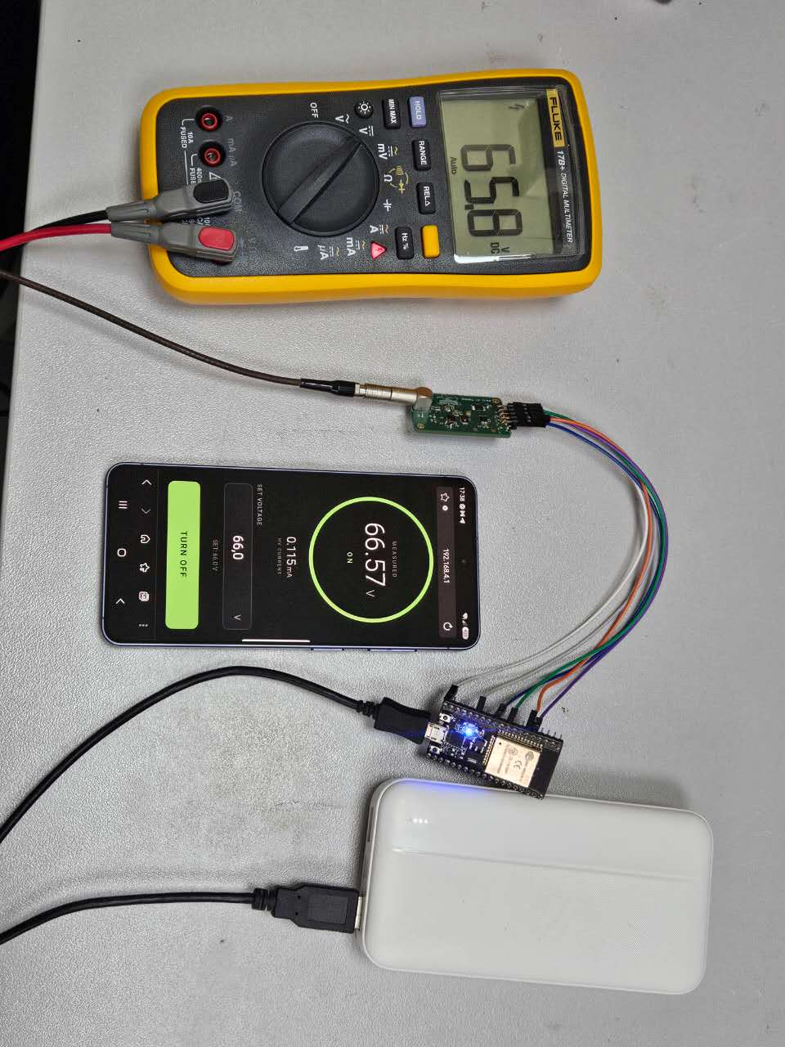
Figure 8: Complete system test setup (5V supply + ESP32 + HV PCB + smartphone + Fluke multimeter)

  - Observed Design Challenges & Mitigation Strategies

The following issues were observed during the initial testing of the prototype, along with the corresponding mitigation strategies

The ESP32 module used for wireless control has the following pinout:
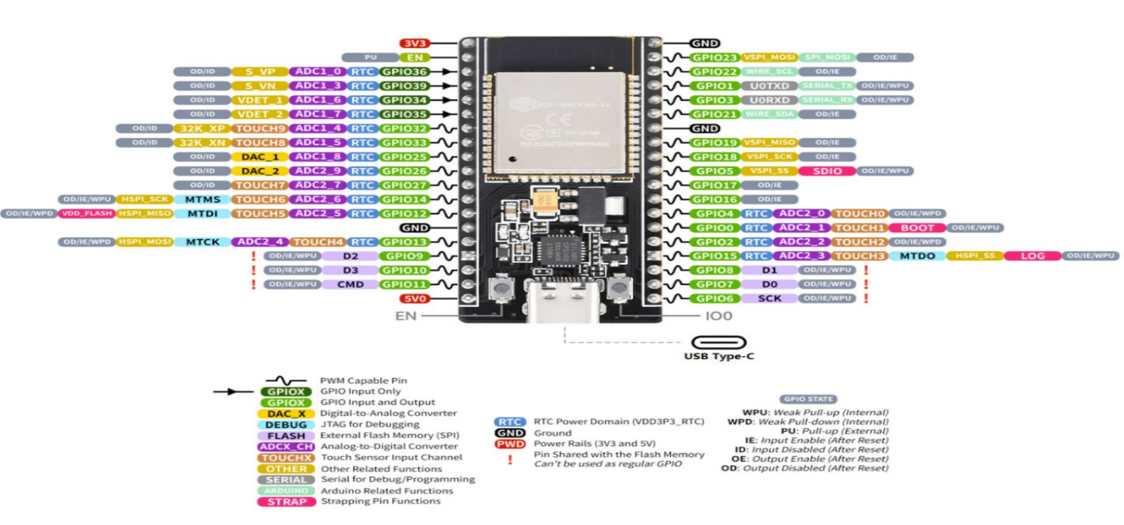
Figure 9: ESP32 pinout diagram

4.3.1 Output Ripple
Observed issue: The switching ripple from the boost converter was initially measured at approximately 0.8mV RMS, which exceeded the <0.5mV RMS target.
Mitigation: A two-stage RC low-pass filter was added at the output: first stage (100Ω + 0.47μF) and second stage (47Ω + 10μF). This reduced the ripple to <0.5mV RMS. The component values can be further adjusted if needed.

4.3.2 Inrush Current at Start-Up
Observed issue: The inrush current charging the output capacitor during start-up briefly exceeded the current limit threshold, causing the protection circuit to engage and prevent the output from rising.
Mitigation: The soft-start feature of the LT3482 was extended by adding a capacitor at the SHDN pin, increasing the start-up time to approximately 5ms. This allows the output voltage to ramp gradually, reducing the inrush current.

4.3.3 Thermal Performance
Observed issue: The LT3482 package temperature rose to approximately 55°C during continuous operation at 80V/4mA output in a 23°C ambient environment.
Mitigation: The thermal via array under the exposed pad was verified to be properly soldered. The temperature rise of ~32°C is within the acceptable range for the QFN package (maximum junction temperature 125°C). No additional heatsinking is required.

  - Test Results (To Be Completed)

TThe prototype was tested with a resistive load and the results are summarized in Table 4. The output voltage was measured with a Fluke multimeter and compared with the web interface readback. The DAC linearity was verified: DAC code 0 corresponds to CTRL=0V, DAC code 174 corresponds to CTRL=1.06V, and the HV output reached 76.3V at the maximum setting with a load current of 1.64mA. The VMON divider ratio was measured as approximately 32.1, agreeing with the theoretical value of 31.3 within 2.5%. The IMON output was verified: the
SET | DAC code | ADC V | ADC I | VADC mv | IADC mv
0 | 0 | 0 | 0 | 142 | 142
10 | 10 | 194 | 141 | 302 | 259
20 | 40 | 571 | 458 | 613 | 520
30 | 61 | 937 | 773 | 915 | 780
40 | 83 | 1337 | 1120 | 1248 | 1066
50 | 106 | 1731 | 1459 | 1571 | 1349
60 | 129 | 2109 | 1790 | 1885 | 1620
70 | 152 | 2493 | 2133 | 2203 | 1903
80 | 174 | 2877 | 2443 | 2519 | 2159
ADC current reading increased with load current, confirming the current monitoring function
Web HV V | Web I mA
0 | 0
9.9 | 208
19.4 | 419
28.5 | 629
38.7 | 861
48.6 | 1087
58.1 | 1308
67.8 | 1537
77.4 | 1742
GPIO25(CTRL) | CTRL mV | HV Keithley mA | V_SENSE pin mv | I_SENSE pin mv | RealHVoutput V
111 | 55 | 0 | 0.1 | 0 | 0
329 | 163 | 206 | 311 | 266 | 9.75
587 | 291 | 410 | 620 | 531 | 19.38
840 | 417 | 609 | 919 | 787 | 28.25
1115 | 552 | 823 | 1242 | 1064 | 38.78
1384 | 685 | 1035 | 1555 | 1340 | 48.5
1638 | 813 | 1239 | 1860 | 1604 | 58
1910 | 944 | 1452 | 2172 | 1879 | 67.5
2152 | 1062 | 1640 | 2450 | 2124 | 76.3

SHDN | 3V3 @80V with load
on | 3.147
off | 3.279

Part 5: Summary & Outlook
This part summarizes the design's contributions and outlines the planned next steps for final validation and integration with the JINR test bench.

5.1 Technical Summary

This project successfully designed and fabricated a compact high-voltage bias supply for SiPM detectors using the LT3482 boost converter. Key achievements include:
A single-stage boost topology with a maximum output of 89.5V (programmable down to 0V)
Precision feedback network providing stable voltage regulation
VMON and IMON monitoring using AD8606 operational amplifiers
A compact 4-layer PCB (30mm × 45mm) with careful layout for noise reduction
Full compatibility with the JINR SiPM test bench interface

5.2 Planned Integration with JINR LHEP SiPM Test Bench

As the final validation step, the designed power supply will be tested in conjunction with the JINR LHEP (MPPC) test bench used for beam tests at the NICA facility. The test will involve:

- Biasing a prototype SiPM array (Hamamatsu S13360 series) with the designed power supply.
- Measuring the SiPM's gain, dark count rate (DCR), and photon detection efficiency (PDE) as a function of bias voltage.
- Comparing the measured gain with the theoretical gain derived from the supply's voltage setting.
A dedicated connector and cabling interface has been designed to ensure compatibility with the existing JINR test bench infrastructure.

5.3 Future Work

Complete the bench testing on the JINR JΦB3 SiPM test bench
Perform temperature cycling tests to verify stability over the full operating range (-20°C to +60°C)
Investigate the addition of an I²C interface for remote monitoring and control using a low-power microcontroller
Reduce the PCB size further (to 30 × 30 mm) by using a 4-layer board and further component miniaturization

References

[1] Hamamatsu Photonics, "What is an MPPC (SiPM)?" [Online]. Available: https://www.hamamatsu.com/eu/en/product/optical-sensors/mppc/what_is_mppc.html.
[2] Z. Ya. Sadygov, Physics of Solid-State Photoelectron Multipliers (in Russian). Dubna: JINR Publishing, 2023.
[3] C. A. Lee, R. A. Logan, R. L. Batdorf, J. J. Kleimack, and W. Wiegmann, "Ionization Rates of Holes and Electrons in Silicon," Phys. Rev., vol. 134, no. 3A, pp. A761–A774, 1964.
[4] Linear Technology (Analog Devices), LT3482 Datasheet: 90V Boost DC/DC Converter with APD Current Monitor, Rev. FA.
[5] D. Renker, "Geiger-Mode Avalanche Photodiodes, History, Properties and Problems," Nucl. Instr. Meth. A, vol. 567, no. 1, pp. 48–56, 2006.
[6] I. Chirikov-Zorin, "Precise Method for Determining Avalanche Breakdown Voltage of Silicon Photomultipliers," J. Instrum., vol. 12, p. C07002, 2017.

Acknowledgement

I would like to express my deepest gratitude to my supervisor, Mr. Mikhail Buryakov, for his guidance and support throughout this project. He has been more than a supervisor — he has been a true role model. I have always admired the way he approaches his work: with the precision and care of an artist, carefully thinking through every detail, every layout, every connection, not just for function but for elegance. He has a rare gift for explaining complex physical principles in the simplest possible terms, and he never runs out of patience, no matter how many times I ask. I have learned from him not only how to design a circuit, but also how to think clearly and work responsibly.

I also wish to thank the other members of the laboratory for their warmth and kindness. They made me feel welcome from the very first day, and they are genuinely interesting and fun people to work alongside. I am grateful for the conversations, the jokes, and the willingness to help whenever I needed it.

Finally, I thank the Veksler and Baldin Laboratory of High Energy Physics at JINR for providing me with the opportunity, the facilities, and the resources to carry out this work. This summer has been an unforgettable experience, both professionally and personally.

Sincerely,
Han sijia

